

Use cases

UML document



October 16, 2019

Lam Nguyen, aurelio hueletl torres, jon ham

Table of Contents

1. Load up the game 2

2. Set options 2

3. Customize character 2

4. Show information 3

5. Decide who go first (Starting the game) 3

6. Start turn 4

6.1. Roll dice: 4

6.2. Resolve dice: 4

7. Roll Dice 4

8. Resolve Dice 5

9. Gain Energy Points 6

10. Gain VP 6

11. Gain Health 6

12. Buy Power Cards 7

13. Using Power Cards 7

14. Smash(attack) 8

15. Eliminating Players 8

16. Player Enters Tokyo 8

17. Player Outside Tokyo 9

18. Winning the Game 9

19. Ending the Turn 9

20. Exit the Game 10

# **Load up the game**

**Description:** Allow the players to start playing the game.

**Preconditions:** The player has installed an IDE that supports Java on their laptop or computer.

**Postconditions:** Theuser is able to play the game if his laptop or computer has enough storage and the source code is available on GitHub.

**Basic steps:**

1. Users download the source code from GitHub and open it on an integrated development environment (IDE) which supports Java
2. The game is designed for 2 – 4 players.
3. When the player runs the game in a IDE, the game panel will be displayed. The player presses the ‘Start’ button in the center of the screen, the game starts.

# **Set options**

**Description:** Set up the options for the game.

**Preconditions:** The player has started the game.

**Postconditions:** The numbers of player is set. A character is picked for each player, each character has a nickname.

**Basics steps:**

1. Players set the number of players who will play the game.
2. There are 6 different types of characters. Each player will choose one character, and no players share the same character.
3. Player can choose a language that they want. Only English is available for now.

# **Customize character**

**Description:** Allow the players to customize their character’ information and appearance.

**Preconditions:** A character is chosen for each player.

**Postconditions:** All chosen characters’ information are customized.

**Basic steps:**

1. After choosing a character, players can set nicknames for the character. The names will be used for the characters throughout the game.
2. Players can change the color of their characters by clicking the advantage button.
3. The max health point (HP) will be set to 10 by default.
4. The max victory point is 20
5. The current victory point will be set to 0.
6. After finish setting the characters’ information. A Player press the ‘Play’ button to start playing the game.

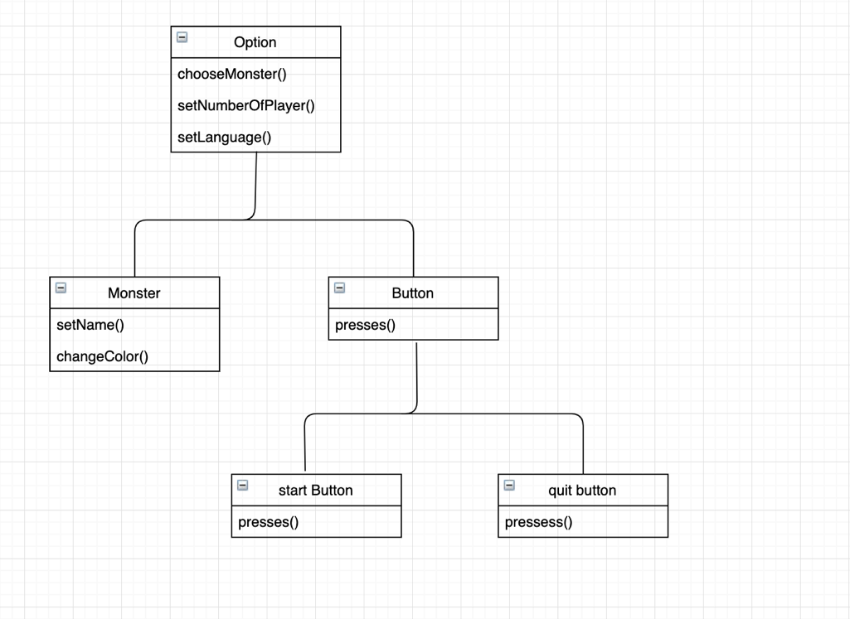

# **Show information**

**Description:** Allow players to see all the current character’s information (nickname, all the points he gets).

**Preconditions:** All players have chosen their characters and set nicknames for them.

**Postconditions:** The player is able to see his character’s nickname and current points during his turn.

**Basic steps:**

1. For each player’s turn, his/her character’s information including nickname, current health points (HP), victory points (VP), and the number of energies will be displayed at the top right corner of the screen.
2. The ‘Roll Dice’ button will be displayed in the center of the screen. The ‘finish’ button will be displayed after the first roll so that players can decide whether they want to keep the result or not.
3. After finishing rolling the dies, the HP and VP will be updated. Players can have the option to buy any cards if they have enough energy points.

# **Decide who go first (Starting the game)**

**Description:** Help players to decide who can play first.

**Preconditions:** Players finished setting up the game and customizing their characters

**Postconditions:** A player get the chance to go first.

**Basis steps:**

1. Each player rolls the 6 black dice. Whoever has the most ‘mash’ results goes first.
2. In case of tie, players roll dice until one player has the greatest number of ‘smash’.

# **Start turn**

**Description:** This is what a player need to do during his turn.

**Preconditions:** Other players finish their turns, and the current player should decide what he needs to stay in the game. (a good strategy).

**Postconditions:** The player finishes his turn and either HP, VP, energy, or smash point is calculated depends on the dice he gets.

### Roll dice:

**Basis steps:**

* + 1. Each dice has 6 symbols that represent the actions you can take on your turn.
    2. On a player’s turn, he/she can roll up to three times. The player can stop rolling at any time.

### Resolve dice:

**Basis step:**

* + 1. The player can resolve his/her dice in any order, but all of them must be resolved.
    2. After finish resolving the dice, the player presses finish button to continue.

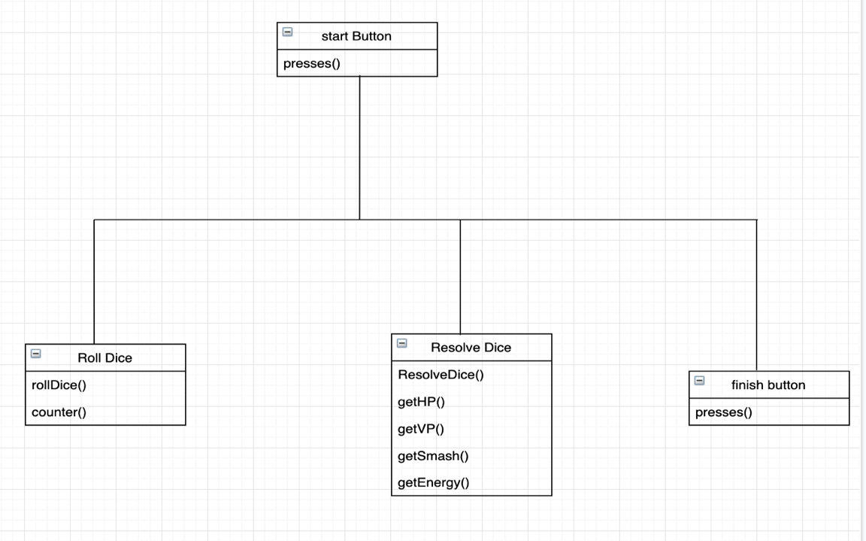

# **Roll Dice**

**Description:** Current player rolls the dice up to three times during his/her turn

**Preconditions:** The game started and now is the current player’s turn

**Postconditions:** The dice are set to be resolved

**Basis steps:**

1. Current player rolls all the dice including the extra dice if any.
2. Based on desired symbols, current player decides which dice to keep.
3. Current player rolls the dice that didn’t warranted the desired symbol.
4. Step 2 and 3 are repeated.
5. Use case ends

Extension:

Player can choose not to roll the dice after step 1 or step 3.

# **Resolve Dice**

**Description:** count all the dice that are facing up the same symbol

**Preconditions:** dice have been rolled

**Postconditions:** action(s) based on the resolved dice is ready to be taken

**B****asis steps:**

1. Players count all the dice that are facing up the same symbol.
2. Depending on each combination of symbols, a particular action is set to happened.
3. Use case ends

# **Gain Energy Points**

**Description:** adds energy points to the current player’s monster overall energy points

**Preconditions:** dice must have been resolved and at least one energy symbol is in the resolved dice

**Postconditions:** the monster’s overall Energy points of the current player have increased.

**Basis steps:**

1. Look for the number of energy points(symbols) in the resolved dice.
2. Add the number of energy points to the overall monster’s Energy points.
3. Use case ends

# **Gain VP**

**Description:** adds Victory Points to the monster’s overall Victory points of the current player

**Preconditions:** dice must have been resolved and at least one Victory symbol is in the resolved dice

**Postconditions:** the monster’s overall Victory points of the current player have increased.

**Basic steps:**

1. Look for the number of Victory points(symbols) in the resolved dice.
2. Add the number of Victory points(symbols) in the combination of symbols to the overall monster’s Victory points.
3. Use case ends

# **Gain Health**

**Description:** adds Heal Points to the current player’s monster’s overall Heal points

**Preconditions:** dice must have been resolved and at least one Heal(heart) symbol is in the resolved dice

**Postconditions:** the monster’s overall Heal points of the current player have increased.

**Basic steps:**

1. Look for the number of Heal (hearts) symbols in the resolved dice.
2. Add the number of Heal points(symbols) in the combination of symbols to the overall monster’s Heal points.
3. Use case ends

# **Buy Power Cards**

**Description:** Determines the conditions in which the user may buy power cards

**Preconditions:** Have sufficient energy blocks

**Postconditions:** User can access the effects of the power card

**Basic steps:**

1. Count the current number of energy cubes owned by the player
2. Select a particular power card that is on display (3 displayed at a time)
3. Note the cost of the particular power card
4. Take equal number of energy cubes as the cost of the card
5. Discard the specified amount of energy cubes back into the energy lot
6. Obtain the chosen power card
7. Set aside to use now or later
8. Use case ends

Extension:

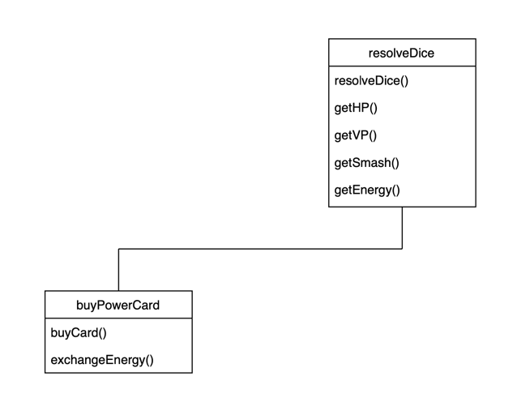 Player can repeat 1-7 as many times as possible as long as he/she has enough energy cubes to utilize for power cards

# **Using Power Cards**

**Description:** use the effect of a Power Card

**Preconditions:** Must own at least a Power Card. It should be current player’s turn. And dice have been resolved.

**Postconditions:** effects(actions) of the Power Card have been applied according to the specifications of the Power Card

**Basic steps:**

1. Take the Power Card that is going to be used
2. Look at the effects(actions) of the Power Card
3. Apply those actions.
4. Keep or Discard Power Card based on the type of Power Card
5. Use case ends

Extension:

Current player can repeat 1-4 if owns more than one Power Card and wants to use other power card.

# **Smash(attack)**

**Description:** causes damage to the other players’ monster

**Preconditions:** dice must have been resolved and at least one Smash(claw) symbol is in the resolved dice

**Postconditions:** other players’ monster’s Heal points have decreased

**Basic steps:**

1. Look for the number of Smash(claw) symbols in the resolved dice
2. Determine the affected monsters
3. Deduct the number of Smash(claw) symbols from the heal points of the previously determined monsters
4. Use case ends

# **Eliminating Players**

**Description:** Instruction on how to eliminate other players in the game

**Preconditions:** Current player must be alive to eliminate other players.

**Postconditions:** One less player in the game

**Basic steps:**

1. When attacking, the player other player loses health points
2. The player being attacked must decrease health gauge by specified number of smash points
3. If the player losing health reaches 0 health, that player is eliminated (i.e. no longer able to play the game)
4. Use case ends

# **Player Enters Tokyo**

**Description:** Writes out the conditions in which a player can enter Tokyo

**Preconditions:** Player must be alive. Tokyo must be empty

**Postconditions:** Player now holds Tokyo

**Basic steps:**

1. Player must enter Tokyo if Tokyo is currently empty (i.e. Tokyo is without a player)
2. Player takes his/her monster and positions it inside the circle of the game board labeled “Tokyo”
3. Player entering Tokyo receives 1 victory point upon entering
4. Player will receive 2 victory points if he/she starts their turn in Tokyo
5. Use case ends

# **Player Outside Tokyo**

**Description:** Effects of players staying outside of Tokyo

**Preconditions:** Player must be alive. There exists a player already holding Tokyo

**Postconditions:** Player may or may not be affected by certain things

**Basic steps:**

1. Player does not remain inside the circle of the game board labeled “Tokyo”
2. Player does not take damage if another player is attacking when he/she is outside of Tokyo.
3. Use case ends

# **Winning the Game**

**Description:** Determine the condition in which the game is won

**Preconditions:** Multiple players in a given game.

**Postconditions:** Player wins the game

**Basic steps:**

1. A player on their turn gains enough victory points to reach 20 total victory points

Variation A: A player, by the use of a power card, gains enough victory points

Variation B: A player, by holding Tokyo, gains enough victory points for a total of 20  
victory points

Variation C: A player attacks with smash points and kills the other player inside “Tokyo” and becomes the last player standing

Extension C: A player may attack from within Tokyo to attack those that are outside Tokyo

# **Ending the Turn**

**Description:** Signals the end of a player’s turn

**Preconditions:** Resolved Dice

**Postconditions:** Player to the left (clockwise fashion) begins their turn

**Basic steps:**

1. Player, with the resolved die, plays their turn
2. Player may choose to buy power cards if desired
3. Player may attack, gain health, or gain victory points based on the resolved die
4. Player no longer has any actions left to play
5. Use case ends

# **Exit the Game**

**Description:** Allows user to quit playing the game

**Preconditions:** Access to computer peripherals such as keyboard and mouse

**Postconditions:** Game is finished, and program exits

**Basic steps:**

1. User may opt to quit the game by using their mouse or keyboard to press “Quit Game” on the GUI at anytime
2. User may force quit the program at any time by pressing the X button on the program window
3. User may close all programs by pressing the shutdown/restart button on the computer